

CARE HOME MANUAL For Care Home Staff

BEET-Winter Trial

Nitric oxide for preventing and reducing the severity of winter viral infections in care (residential and nursing) homes


Authors: Philip Bath (Chief Investigator), Amanda Avery (Dietetics),

Charlotte Bath (Co-ordinator), Chris Coleman (Virus Expert), Adam Shen Lim (Respiratory Infections Expert), Simon Royal (General Practitioner), Andrew Webb (Beetroot Juice Expert)…
Gordon (Care Home Expert), Diane Havard (Senior Trial Manager), Wei Shen Lim etc

BEET-Winter@nottingham.ac.uk

0115 823 1701

Nitric oxide for preventing and reducing the severity of winter viral infections in care (residential and nursing) homes BEET-Winter

Contents:

- Introduction
- What is the purpose of the trial?
- How do I set the trial up?
- Who can enter the trial? (inclusion/exclusion criteria)
- How do I enrol a resident?
- Participant / Consultee Information Sheets
- Beetroot juice shots
- Measuring urinary and salivary nitrate and nitrite
- Dietary data collection
- Symptoms for first/second/third events
- Entering data (logging-in, forms)
- Withdrawing from the trial, stopping treatment or missing a follow-up
- Summary of the trial
- Frequently Asked Questions

1. INTRODUCTION

The University of Nottingham are sponsoring a trial which is looking at whether residents in Care Homes can be recruited into a trial assessing the effectiveness of nitric oxide, given as beetroot juice, for preventing winter infections in Care Home residents.

Your Care Home has agreed to take part in the trial. Between twelve and seventeen residents from your Care Home will take part in the trial, which will run for 4 months. The trial will take approximately 4-6 weeks to set up, followed by 2 months (60 days) of residents taking beetroot juice. Residents will have a follow up one month after they have finished taking the beetroot juice. Once all residents have completed the trial, the trial will finish in your Care Home.

2. WHAT IS THE PURPOSE OF THE TRIAL?

- To see if it is feasible to recruit residents in care homes into a trial aiming to reduce winter infections
- To see if nitric oxide given as dietary nitrate reduces winter infections and their severity in care homes residents

Winter infections are those that occur mostly during late autumn, winter and early spring. These include influenza (‘flu), the common cold and norovirus (winter vomiting). This will also include COVID-19 (which is causing the current coronavirus pandemic) since it is likely to be especially predominant during winter.

3. HOW DO I SET THE TRIAL UP?

Care Home Manager
Having expressed interest in the trial, the care home manager will have:
- Had a follow up phone appointment with the trial coordinator to discuss the trial in more detail
- Confirmed that the care home (and staff) have capacity in their working day to participate in the trial
- Agreed a contract with University of Nottingham
- Identified lead staff who will be trained and take part
- Let those staff see the training slides and join a full briefing and Q&A session with trial team
- Find a secure cool place to store the beetroot juice boxes in

4. WHO CAN ENTER THE TRIAL?

Care Home criteria
Inclusions
- A care home with CQC of Good or Outstanding

Exclusions
- Staff “live” in care home
- Small homes <20 residents

Resident criteria
Inclusions
- Age >=65 years
- Taking a normal-consistency or soft diet
- Willing to take treatment having taste-tested a beetroot shot

Exclusions:
- Participating in another intervention trial
- Has not given consent to enter trial (resident, or family if resident lacks capacity)
- Using a thickener in food
- Feeding tube
- Using antiseptic mouthwash, such as Corsodyl, Listerine, often including chlorhexidine (an antiseptic)
- Currently has an acute infection requiring hospitalisation
- Identified by care home staff to be in last few days of life
- Short-term respite care
- Care home staff
- Takes beetroot juice daily
- Has a beetroot allergy

5. HOW DO I ENROL RESIDENTS?

Selection of residents for the trial needs to be done at random. Residents do not need to have capacity, but consent will need to be given either by the resident or by their nominated relative/next of kin.

5.1: Identifying suitable residents

In order to randomly select eligible residents, please follow the below protocol.

- Pull together an excel spreadsheet of all residents living at the care home, listed in alphabetical order by surname.

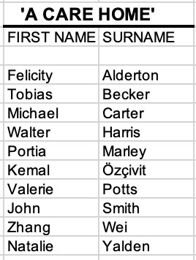

- Notify the Trial Manager of the number of residents currently living in your care home, i.e. in the example above, a total of 10 residents.

- The Trial Manager will then send back a list of numbers mixed up in random order. Work down the list, assigning the first number provided against the first name on the list, the second number against the second name, and so on.

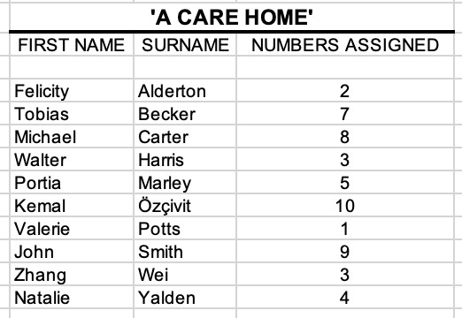

- Work through the list in numerical order, starting at 1, to identify the residents (up to a max of 17) which have all of the inclusion criteria, and none of the exclusion criteria (see section 4) i.e. if Valerie Potts fulfils all the criteria then move on to next stage. Repeat this for each of the residents in numerical order until you have at least 12 residents.

5.2: Assessing capacity in order to give to consent– ‘3 question approach’

Of this group of up to 17 residents, ask each resident whether they might be interested in joining a trial which aims to reduce wintertime infections. If they say yes, you will need to determine whether the resident has sufficient capacity to give consent, or whether we need to speak to their nominated relative.

If they lack capacity and are unable to say if they are interested, please move straight to 5.3.

For those residents who answered yes, each resident will need to be assessed using the ‘3 question approach’. To do this, you will need to individually tell each resident the following things about the trial:

- We want to prevent infections and reduce their severity;
- We will ask you to drink beetroot juice every day for 2 months;
- We will ask you questions at 2 months to see if you developed any infections and, if so, how severe these were.

After telling the resident the three things, please ask the resident the following questions:

- What is the aim of the trial? = ”prevent infections”
- What do you need to drink? = “beetroot juice”
- What will we do at 2 months? = “ask questions”

If all the key underlined information is mentioned and correctly given, then the resident has sufficient capacity to give consent.

5.3: Informing residents/relatives

If a resident is deemed to have capacity and is interested, please give them the Participant Information Sheet (section 6) to read; if appropriate, read them the sheet taking account of any sight or hearing problems. If a resident does not have capacity, please call their nominated relative/next of kin, and email them the Consultee Information Sheet.

After they have read the sheet, please answer any questions that the resident or their relative might have.

Then ask them if they are interested in participating/their relative would like the resident to join the study.

If the resident/relative says no, then clearly state that they will not be in the trial. Please record this decision in the resident’s notes/records.

If the total number of residents who are interested in joining the trial falls below 12, then go back to 5.1 and work through the list of residents numerically until you can identify the next eligible resident(s).

5.5 Beetroot taste test
Once a resident (or next of kin) has read the Participant/Consultee Information Sheet, the resident needs to taste test a beetroot shot. Open a shot from the tester pack and ask the resident to drink the whole shot. This can be done with a straw (if helpful) or mixed with another juice/water in a glass. If they can drink the whole shot, then they are a candidate for the trial.

If they cannot drink the whole shot, or don’t want to finish the shot, then clearly state that they will not be in the trial. Please record this decision in the resident’s notes/records.

If the total number of residents who are able to consume the juice and have given consent falls below 12, then go back to 5.1 and work through the list of residents numerically until you can identify the next eligible resident(s).

5.6 Consent Form

Once a resident has demonstrated the ability to consume the beetroot juice and have expressed that they wish to enter the trial, they (or their nominated relative / next of kin) will need to sign a consent form.

5.6.1 Residents with capacity

- The digital consent form in the REDCap database will need to be completed. This is the ‘Consent Form’ in the ‘SCREENING’ section on the database.

5.6.2 Residents without capacity

- A Consultee Advice Form will need to be completed by the resident’s nominated next of kin/relative in order to give consent by proxy. If there is no next of kin, or they do not respond in 3 days, the Care Home Manager can complete the Consultee Advice Form and give consent by proxy on behalf of the resident.

- The Consultee Advice Form is automatically emailed to the next of kin (when the email address is provided in ‘Resident’s Capacity’ in the ‘SCREENING’ section on the database).

- When completed, the Consultee Advice Form in ‘SCREENING’ Section is saved.

6. PARTICIPANT / CONSULTEE INFORMATION SHEETS
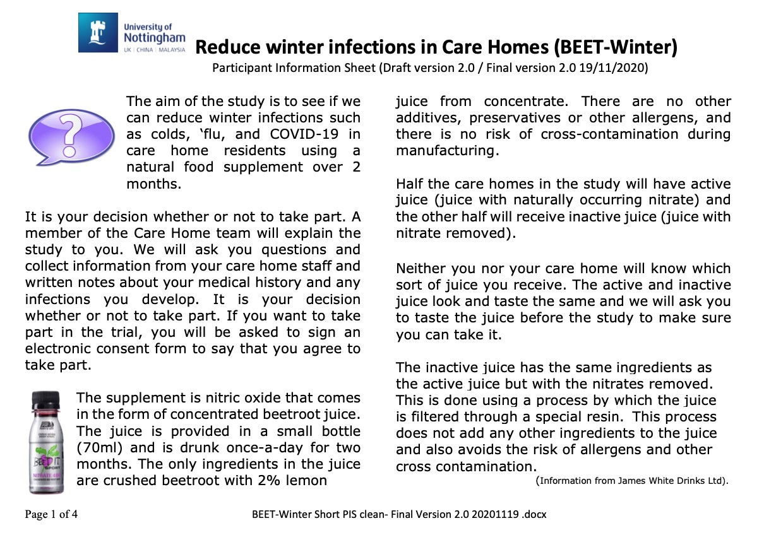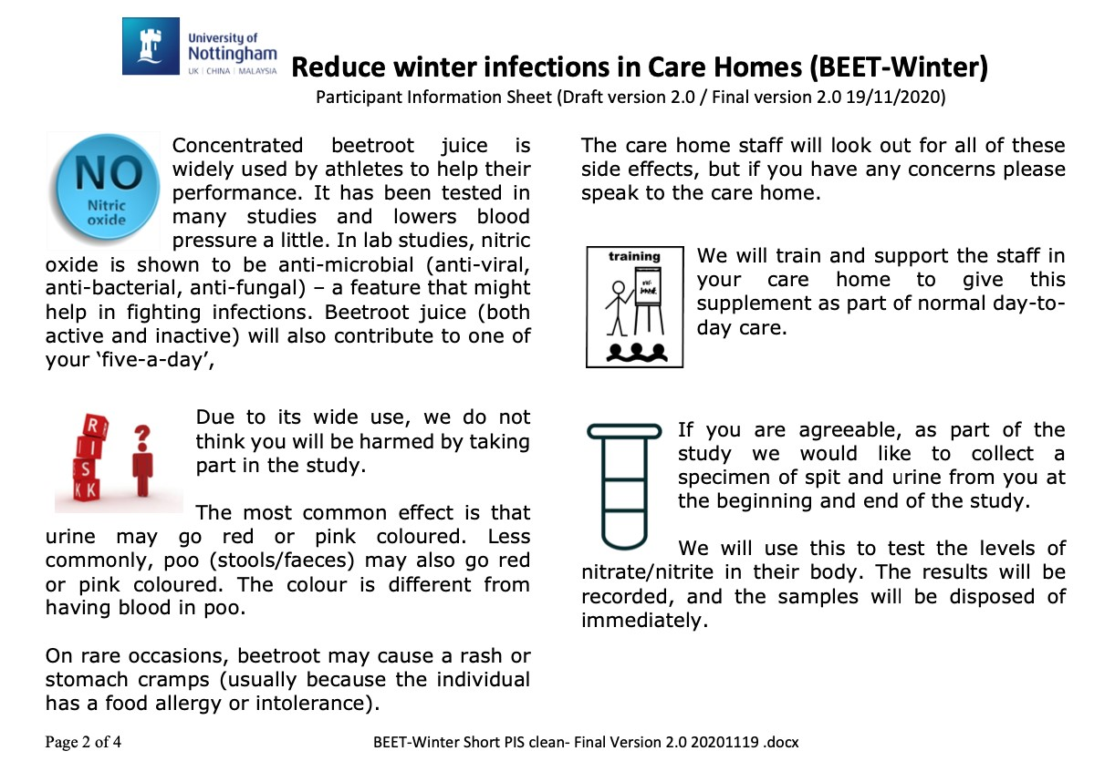

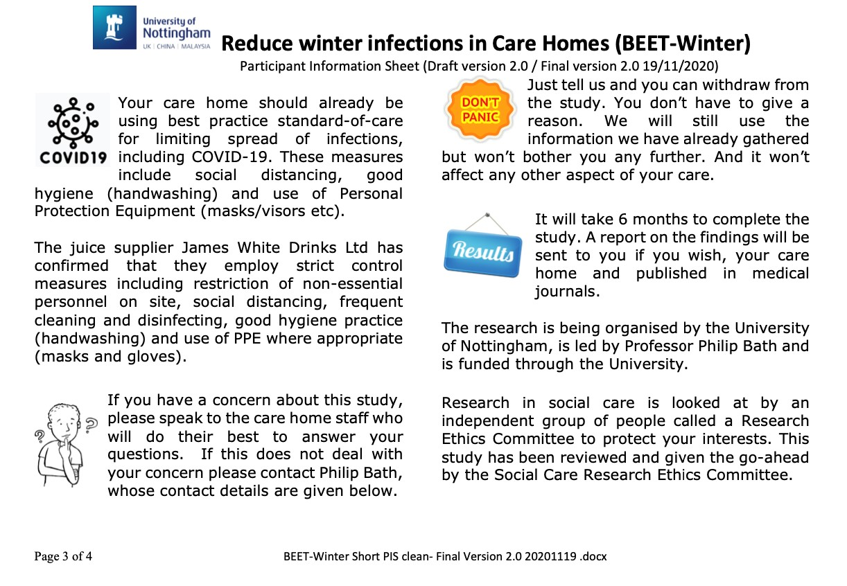

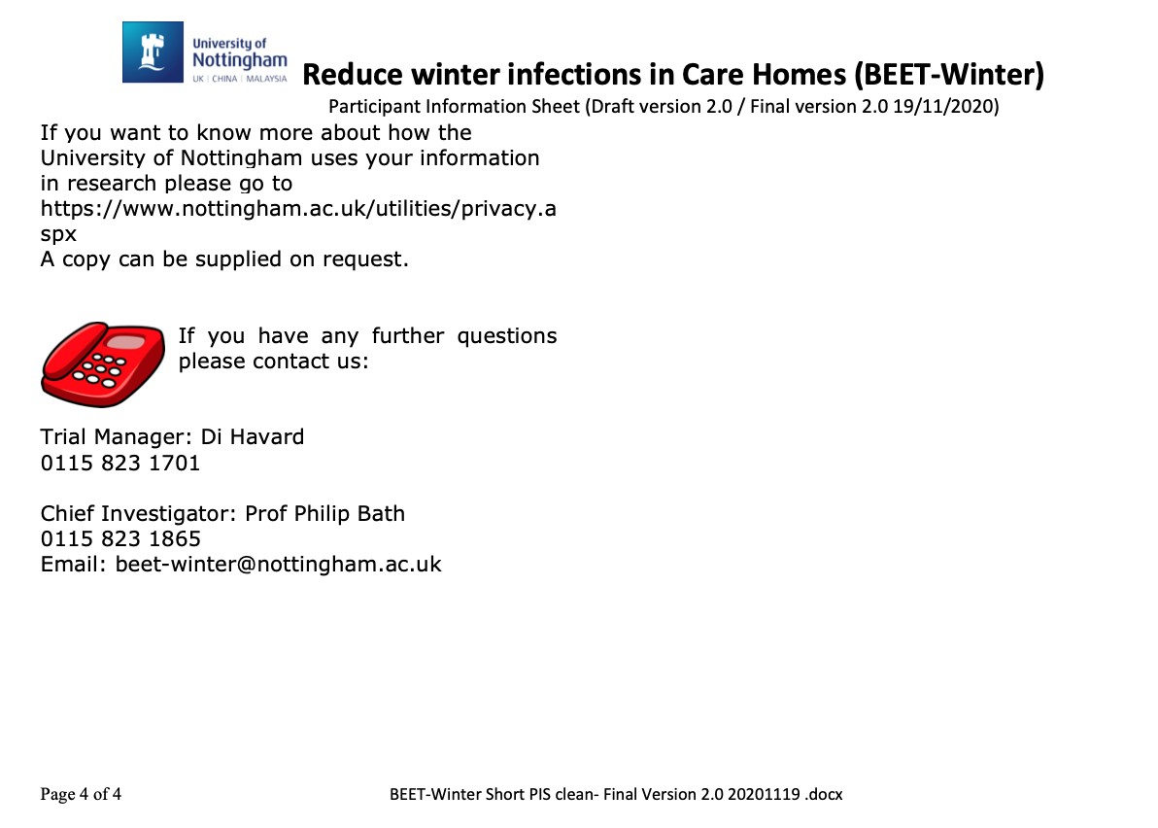
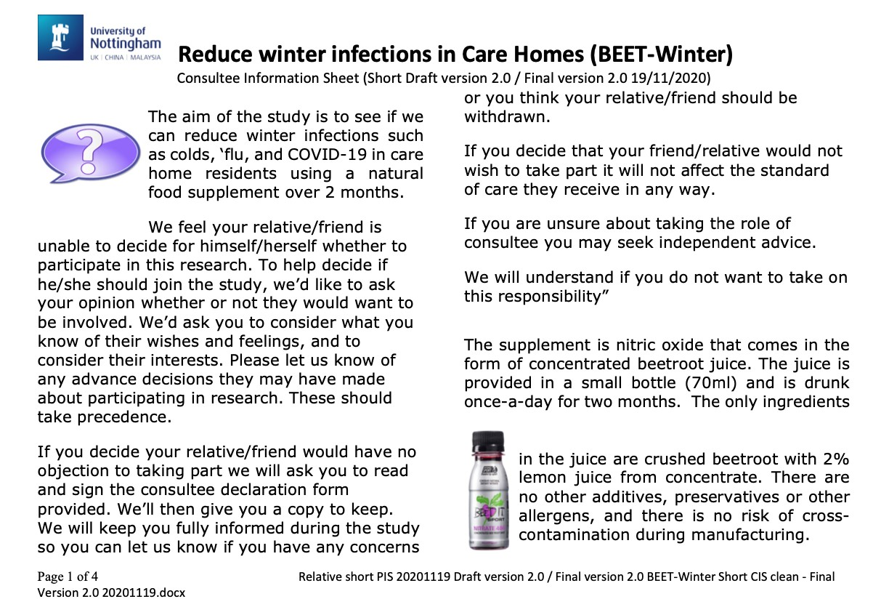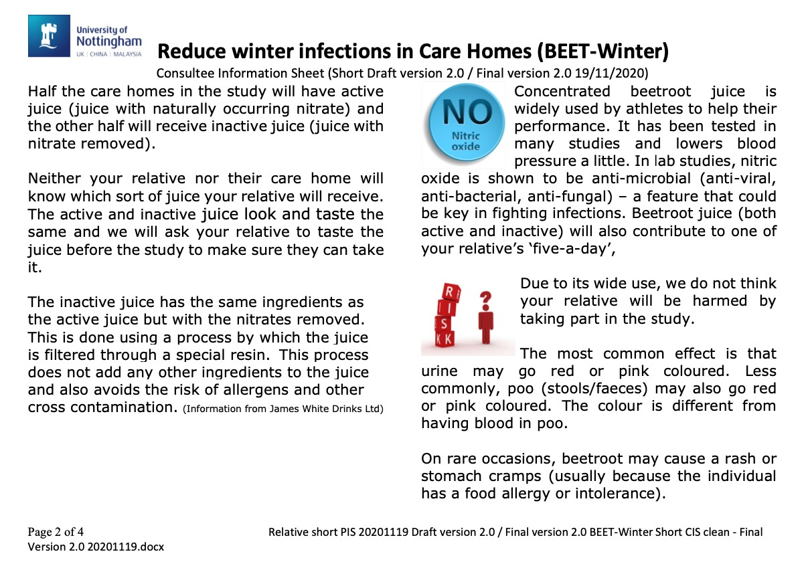
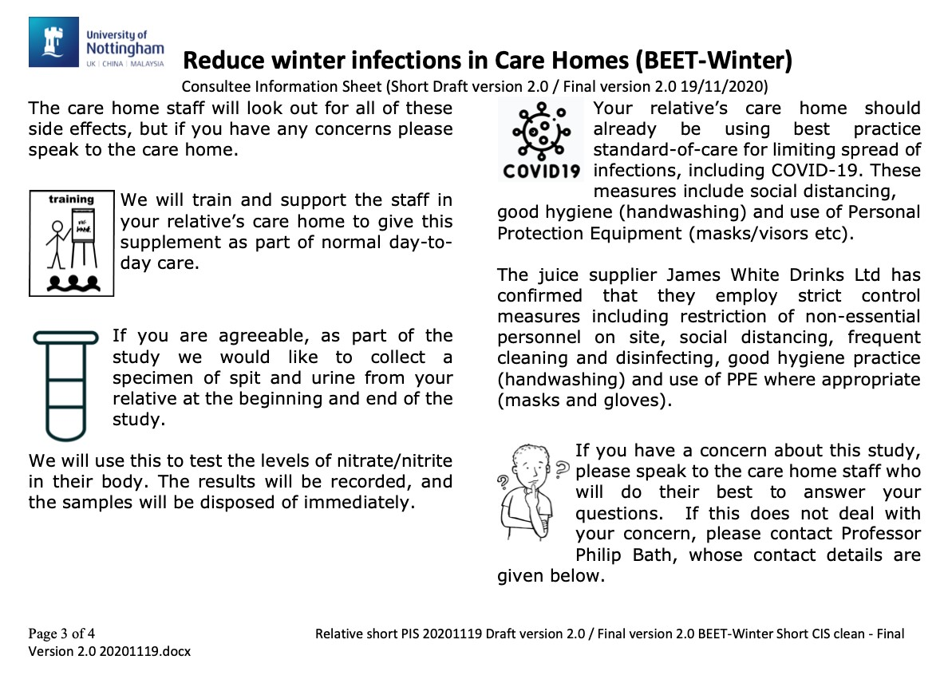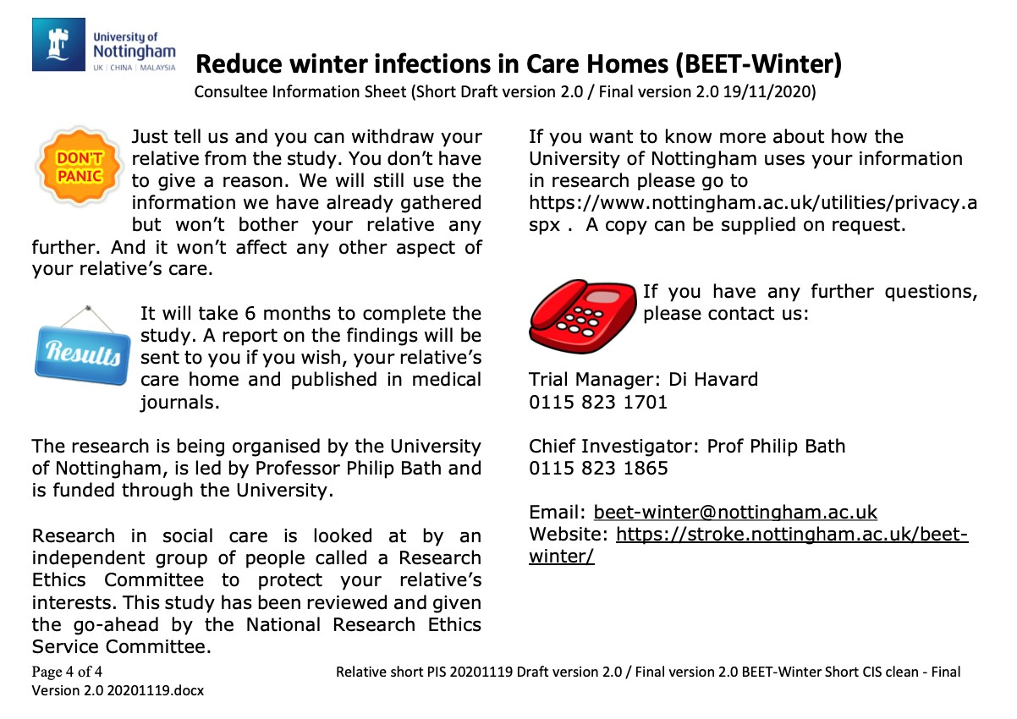

7. BEETROOT JUICE SHOTS

Requirements: Each resident will be allocated 60 daily shots; these will come in four beetroot juice boxes each containing 15 shots and will be supplied directly to the care home by James White Drinks Ltd.

For example, a care home with 12 participating residents will receive 48 boxes. These can be stored at room temperature and will have a shelf life that is much longer than the length of the trial. Half the care homes will receive active beetroot juice (containing nitrate) and half the care homes will receive inactive beetroot juice (not containing nitrate).

The beetroot juice bottle contains 98% concentrated crushed beetroot and 2% lemon juice. There are no other additives, preservatives or other allergens, and there is no risk of cross-contamination during manufacturing. The nitrate-free juice is the same as above, but the nitrates have been removed.

The resident should drink a beetroot shot once a day each day for 60 days. Timing of the juice is up to the Care Home but should be at the same time each day.

Possible Side Effects
- The most common effect is that urine may go red or pink coloured (“beeturia”). The colour is different, and urine is clear, so it looks different from having very concentrated or infected urine.
- Less commonly, poo (stools/faeces) may go red or pink coloured. The colour is different from having blood in poo.
- Rarely, beetroots may cause a rash or stomach cramps. Please ring (0115 823 1701) or email the Trial Team (beet-winter@nottingham.ac.uk) if you have any concerns about potential side effects.

The End of Treatment form asks questions about whether any of these side effects occurred.

8. MEASURING URINARY AND SALIVARY NITRATE AND NITRITE

Requirements: A urine and saliva specimen collected just before the test and use of the supplied nitrate/nitrite dip stix test (note - this does not use a normal urine test dip stix kit). Please watch the video first.

8.1 Urinary nitrate and nitrite
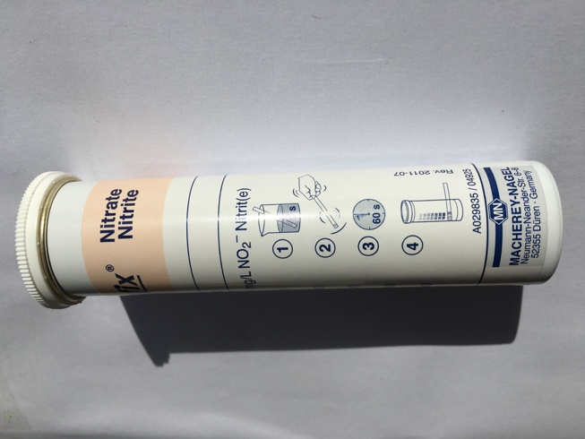
Ask the resident to pee into a container, remove a test strip from the Quantofix tube, dip the test strip into the urine for 1 second, remove the test strip and allow excess urine to drain off, wait 60 seconds and then read off the nitrate and nitrite concentrations from the colour chart running up the side of the Quantofix tube. Immediately take a photo on a smart phone/tablet (with the resident’s initials, care home name and date/time showing in the background on a bit of paper) and upload to the trial database.

8.2 Salivary nitrate and nitrite
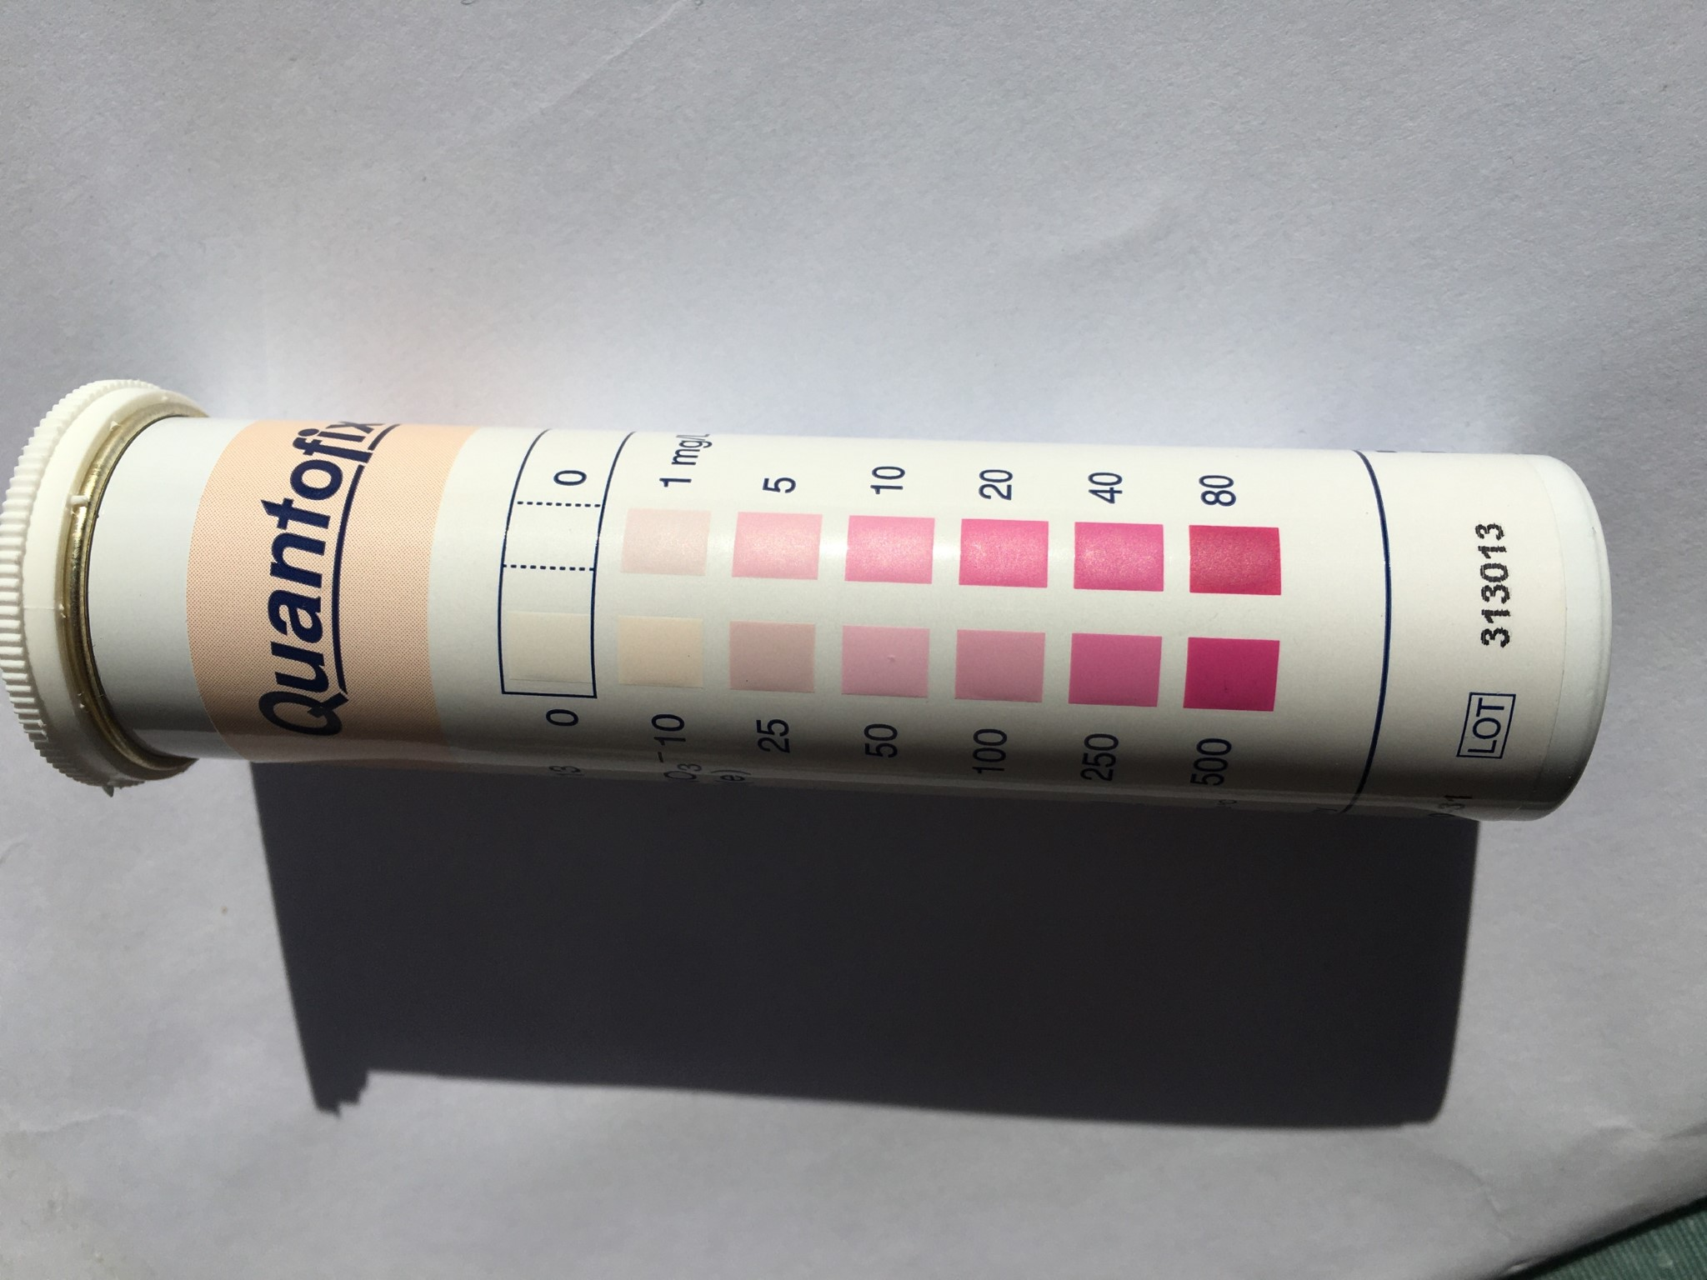
Repeat the process above for a saliva sample. Ask the resident to spit at least three times into a container, dip the test strip into the saliva for 1 second, remove the test strip and allow excess saliva to drain off, wait 60 seconds and then read off the nitrate and nitrite concentrations from the colour chart running up the side of the stix tube. Immediately take a photo on a smart phone/tablet (with the resident’s initials, care home name and date/time showing in the background on a bit of paper) and upload to the trial database.

Urinary and salivary nitrate/nitrite will be measured just before the first drink at baseline, on Day 14, Day 60 (approximately 2 hours after taking the last drink) and again at Day 90. If residents refuse to drink further beetroot juice please test their urinary and salivary nitrate and nitrite as soon as possible after that decision.

9. DIETARY DATA / FOOD INTAKE COLLECTION

For each care home resident, the care home will upload the below to the database on the following four days: baseline (day 0), juice check day (day 14), end of treatment (day 60), and end of follow-up (day 90):

- a menu card for that day. Please indicate the resident’s choices on each of the three days. Please also include the resident’s initials, Care Home name and date/time.
- a photograph of the meal (we suggest this is done at lunch) chosen by the participant when it is presented to them and then after their plate/dish is cleared so that we can have an accurate picture as to how much is eaten. Again, please add information on the resident’s initials, Care Home name and date/time.

10. SYMPTOMS OF FIRST/SECOND/THIRD EVENT

Requirements: Information about any event that affects the resident, if any, after the start of the trial (from day 1) needs to be collected.

This can be any of the following:
- Any infection is included, whether related to chest, gastrointestinal, urinary, skin or any other type
- A heart attack/ stroke
- Anything which required medical intervention

What constitutes an infection? Although all of us get minor infections causing minor symptoms (tickly cough, occasional sneeze or cough, minor temperature, minor rash etc) we are only interested in those infections that cause symptoms that lead to some type of intervention such as:
- For symptoms which require the following, e.g. paracetamol to lower temperature or treat headache, nasal decongestant to reduce sneezing and nasal drip, antibiotics etc.
- That lead to a telephone call or internet advice to healthcare services, e.g. call to 111 or access to 111 by internet, call to GP for advice, or leading to a GP visit.
- That lead to hospitalisation.
- That leads to death in the Care Home.

11. ENTERING DATA

The nominated senior nurse/ team leaders will be responsible for entering data for each resident into the online database – REDCap. The database is accessed online via a standard internet browser (Chrome, Firefox, Safari), i.e. on a computer (PC or Mac), tablet (Android or iPad) or smart phone (Android or iPhone).

Data will be entered at a number of phases of the trial. The forms are listed below, with details of each one in section 11.3.

Timing | Form
Screening | Resident’s capacity
 | Consent Form
 | Consultee Advice Form
 | Start
 | Screening
Baseline | Enrolment Start
 | Medical History
 | Vitals
 | Drug and Vaccination History
 | EQ5D
 | Clinical Frailty Scale
 | Cognition Impairment Test
 | Barthel Index
 | Nitrate/nitrite Measurement
 | Food Intake
START beetroot juice
Day 14 - Beetroot juice check | Beetroot Juice follow up
 | Food Intake
First Event | Symptoms & diagnosis
Second Event | Symptoms & diagnosis
Third Event | Symptoms & diagnosis
Day 60 – Food | Food Intake
 | Nitrate/nitrite Measurement
Day 60 - End of treatment | EQ5D
 | Clinical Frailty Scale
 | Cognition Impairment Test
 | Barthel Index
 | End of Juice
 | Clinical Start
 | Clinical End
STOP beetroot juice
Day 90 | End of follow-up
 | Nitrate/nitrite Measurement
 | Food Intake
End of trial | End of study

Questions are designed to be quick and straight-forward to answer and mostly comprise yes/no answers, or multiple choice.
It is important that each form is completed as soon as the information is due. Ideally, data should be entered straight into the database. Alternatively, it could be collected onto paper forms and then entered into the database.

NB. We will provide a digital juice log to record daily juice doses (including any missed doses), but this could also be collected on the resident’s daily medication log, and the trial log updated at regular intervals. This data will be collected on the End of Juice form.

11.1 Setting up and enrolling residents

Once your care home has been enrolled in the trial and set up on the database, the trial office will set up individual log-ins to the REDCap database using the staff email address(es) provided by your care home. Multiple team members can share a central log-in if helpful, as each time a form is completed on the database, the name and signature of the staff member is required to be entered on the form.

To log-in, enter the username and temporary password (which will be sent to you separately). The temporary password will need to be reset.

Once logged in, click ‘My Projects’ (Fig.1) to take you through to the Projects page. Then click on project ‘BEET-Winter’ to take you to the database (Fig 2).

Fig. 1



Fig.2

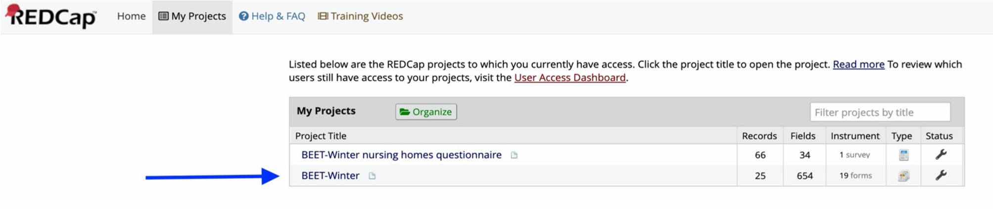

After clicking project ‘BEET-Winter’, you will be taken through to your care home’s page (in the example below, this is ‘999 Test Care Home). On your care home’s page you will see a list of ‘Current Users’. This is a list of all staff registered at the care home, and those in the BEET-Winter trial team who have access to this care home’s data.

In order to enrol a resident, click ‘Add / Edit Records’ in the toolbar on the left of the page (Fig. 3). Once in the ‘Add / Edit Records’ page, click ‘Add new record’ (Fig 4.)

Fig. 3

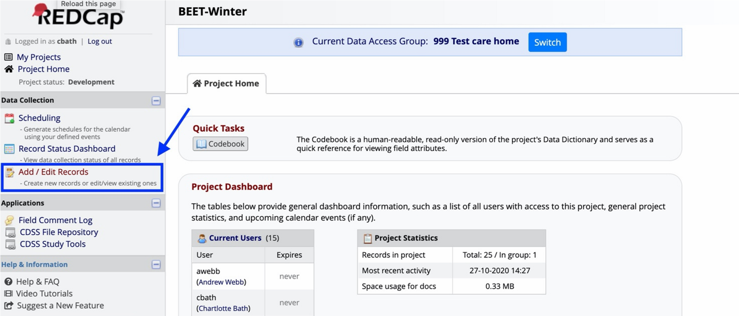

Fig. 4

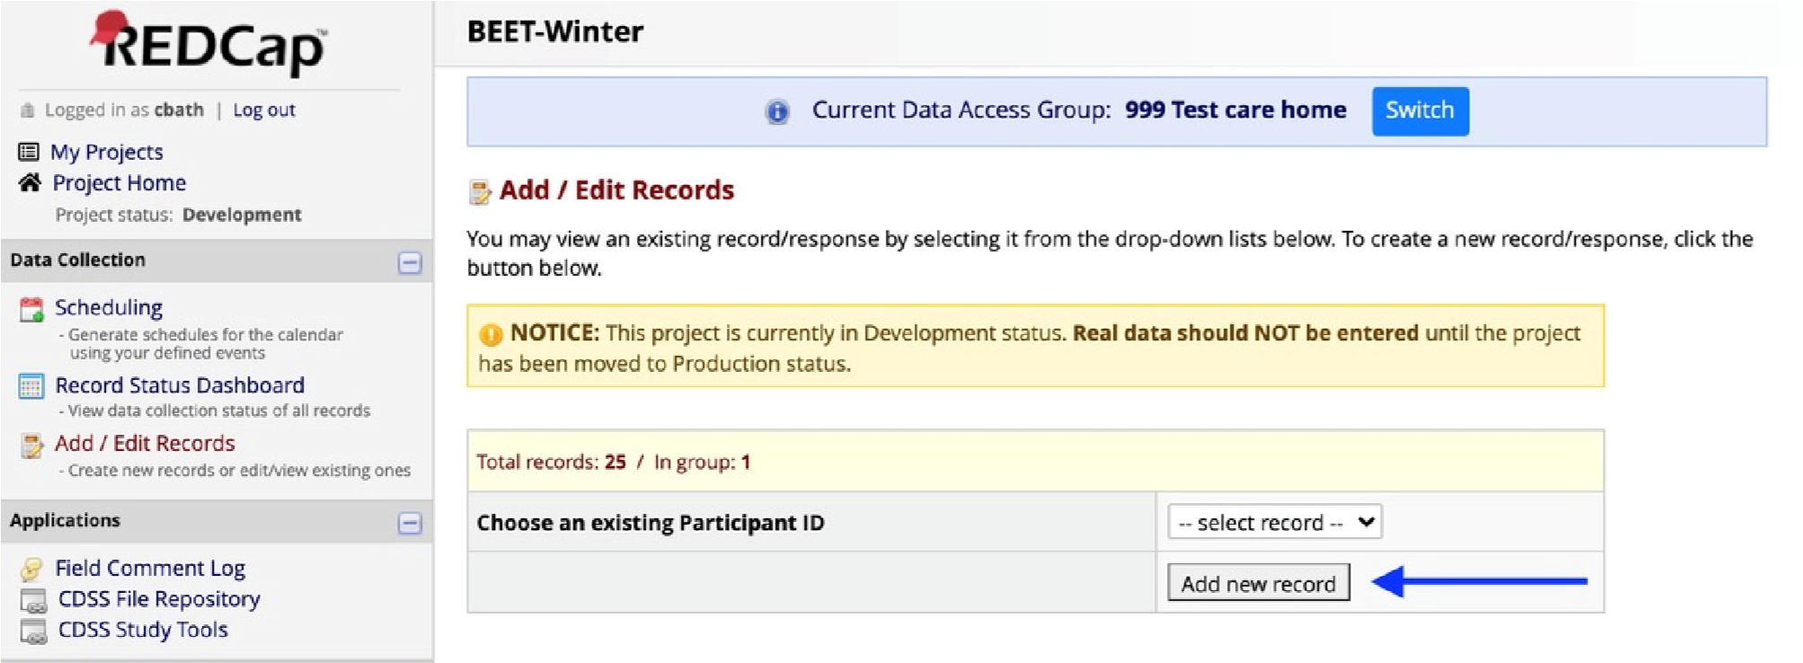

This will generate a Resident ID (comprising the Care Home ID and Individual Resident Number) and bring up the resident’s individual Record Home Page.

The grid displays the form by form progress of the new resident’s records. To fill in each form, click on the button in each section (Fig. 5). A summary of each form and at what point it needs to be completed can be found in section 11.3.

Fig 5.

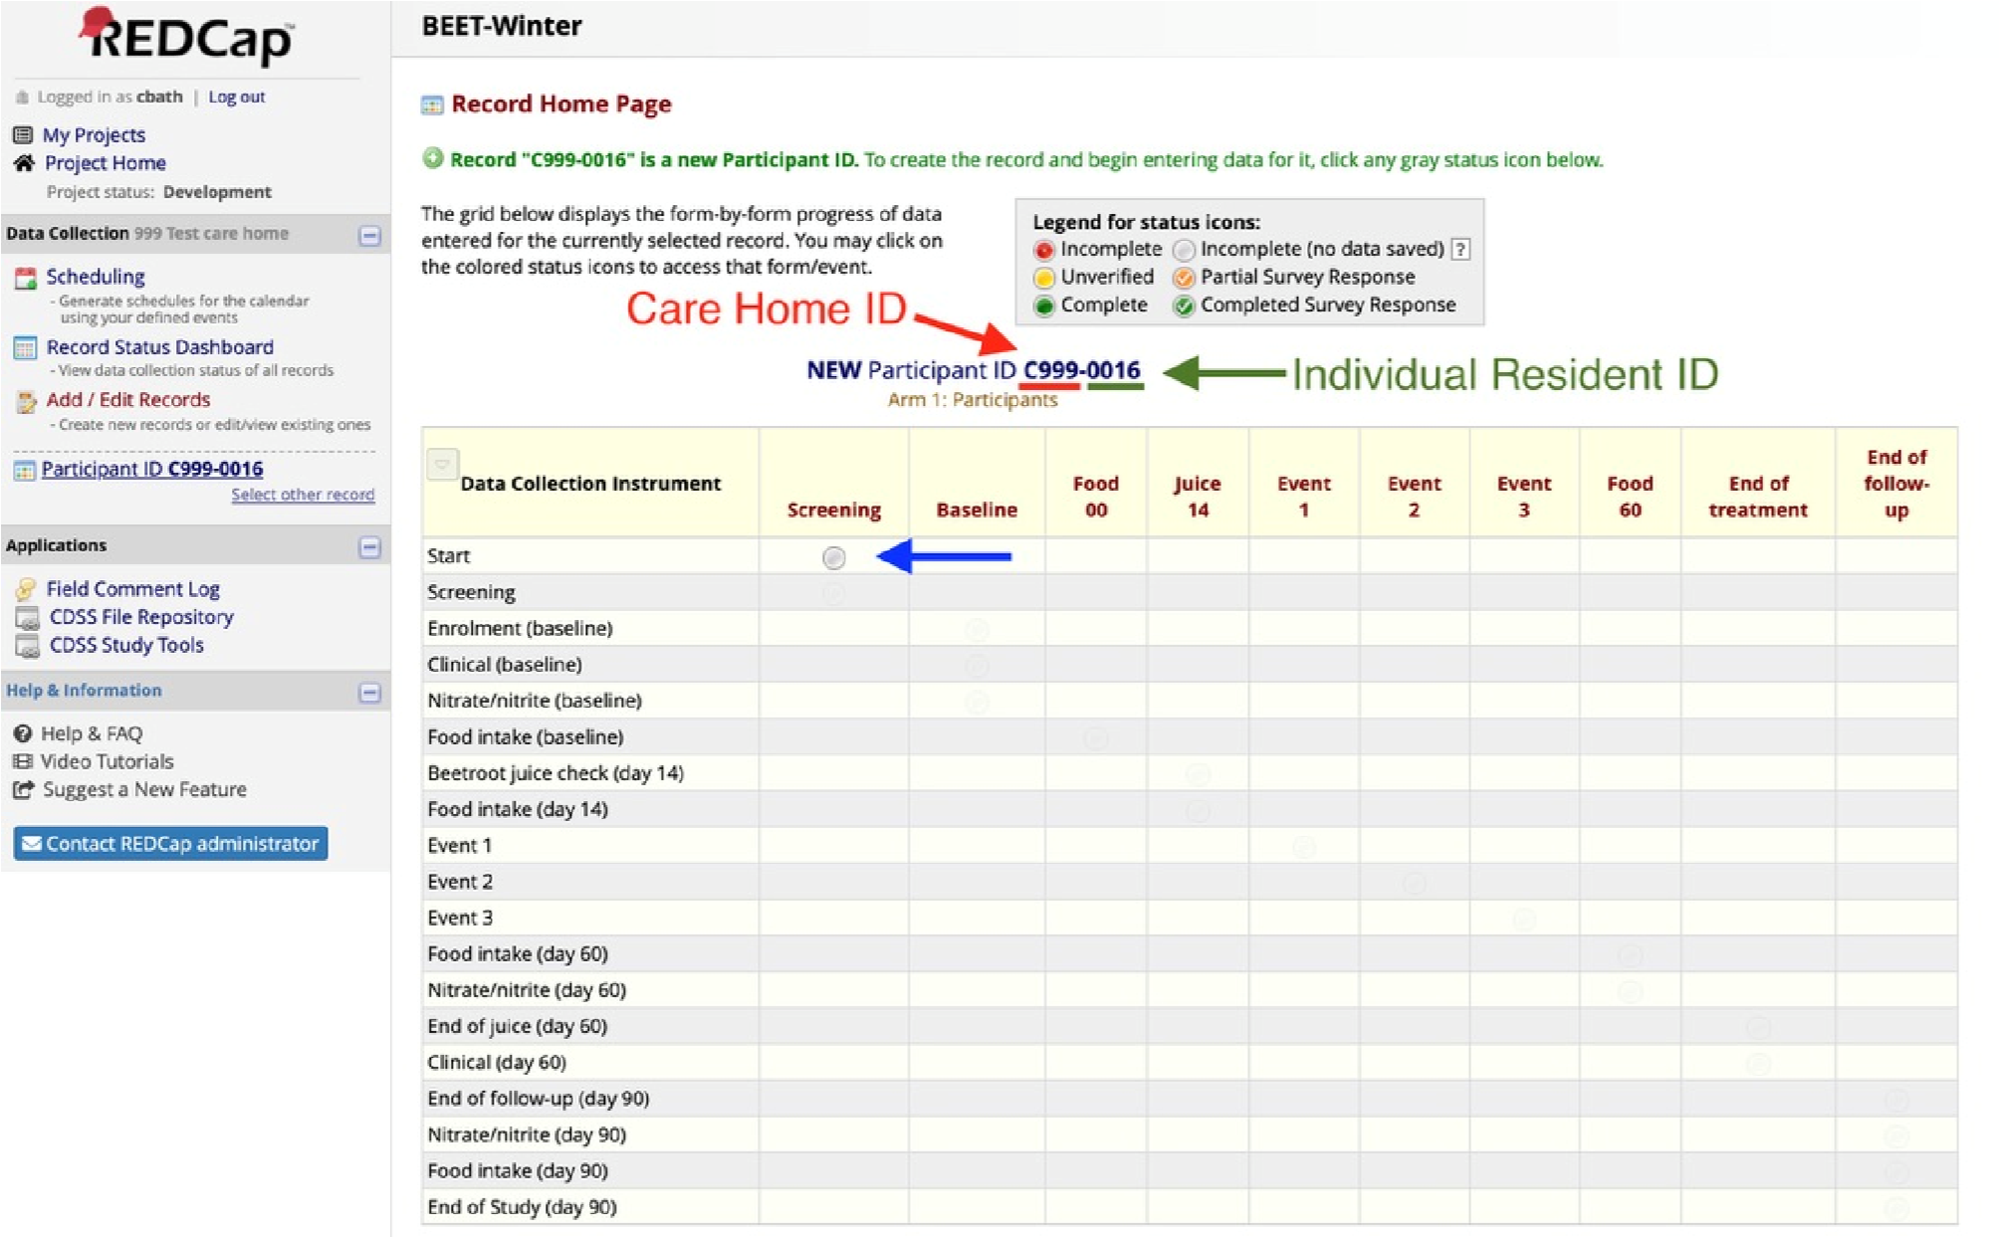

Once the Screening and Enrolment forms are completed, the initials of the resident will top each form (Fig 6.).

Fig 6.

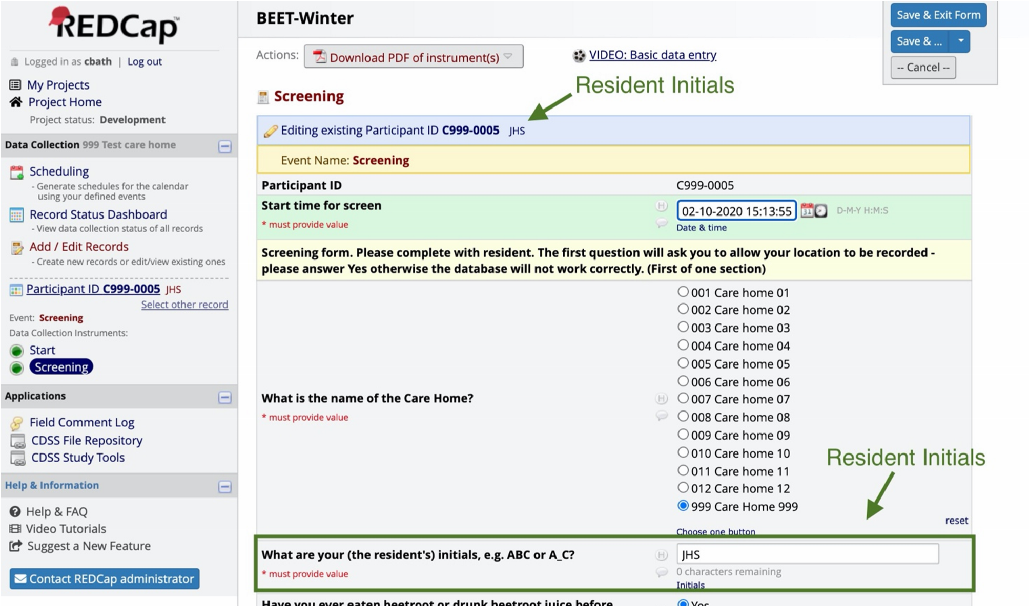

11.2 Updating resident records

If you want to update a current Resident’s records or check a status, you can select the record through the ‘Add / Edit Records’ tab (see Fig 7).

Fig 7.

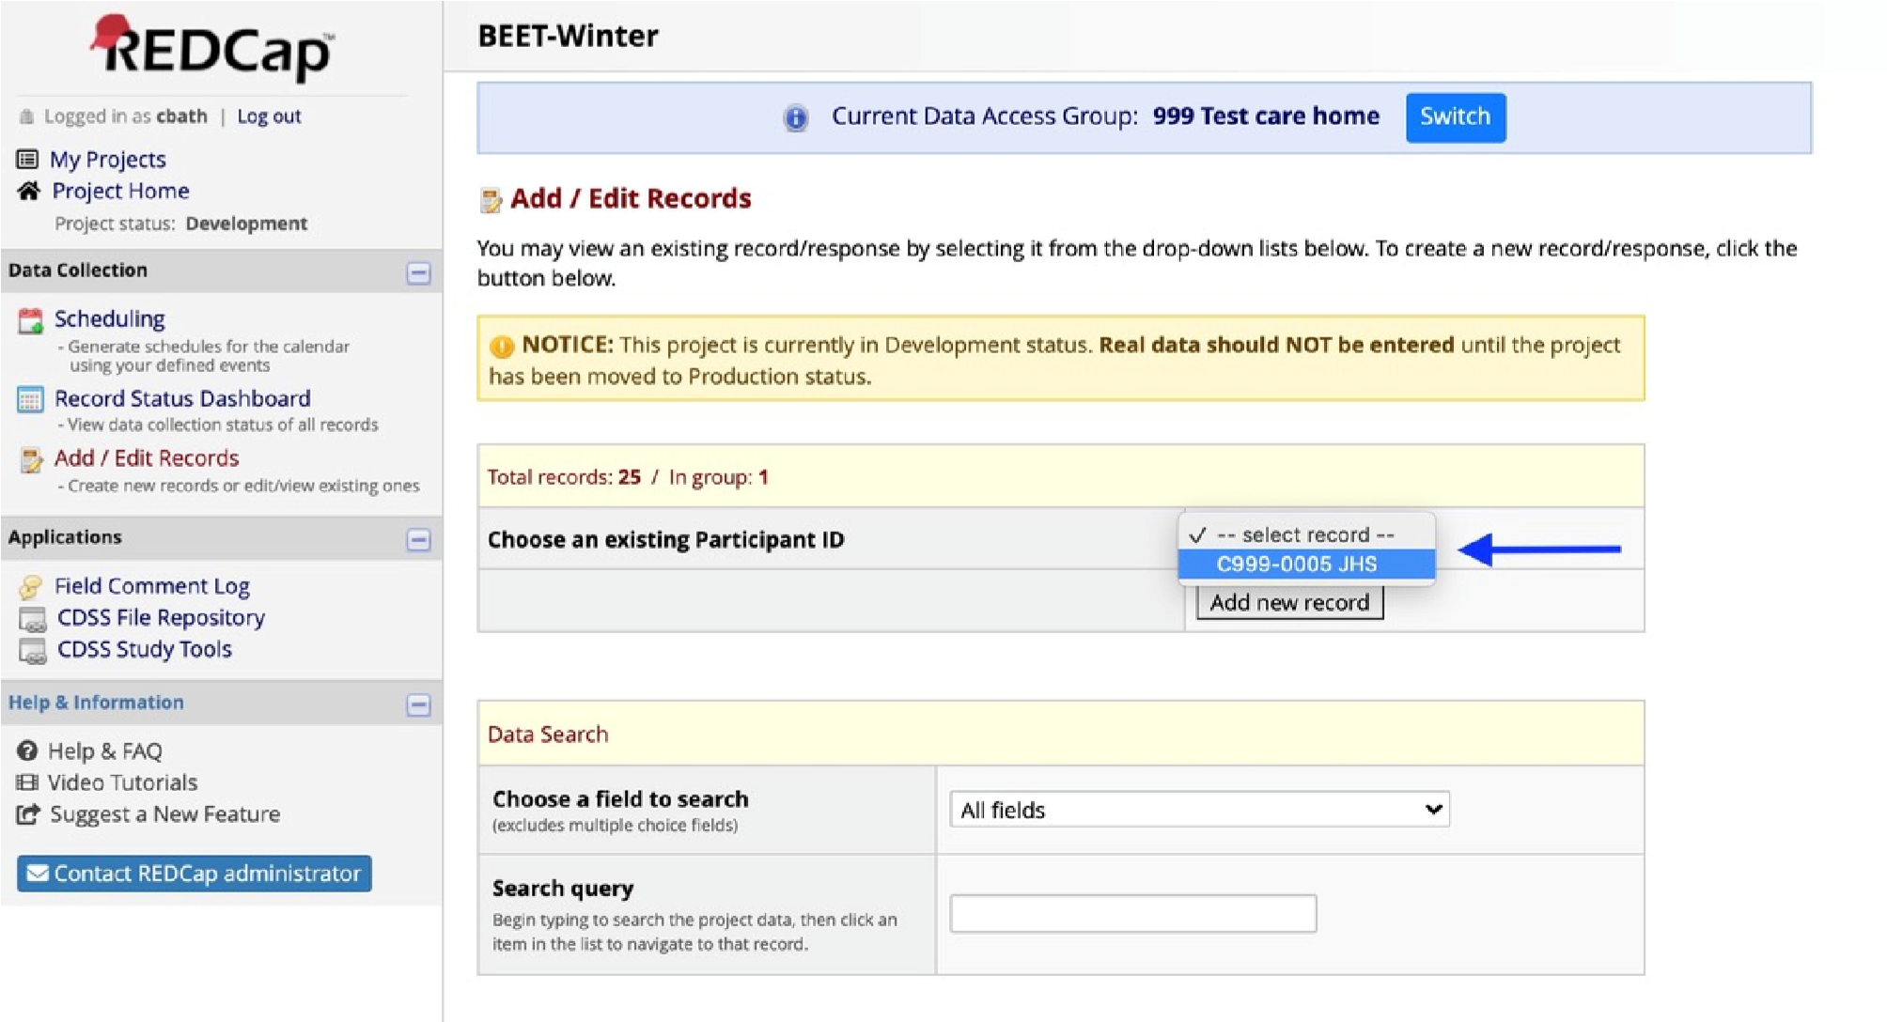
Alternatively, to see all residents at your care home enrolled in the trial, click Record Status Dashboard (Fig 8).

Fig 8.

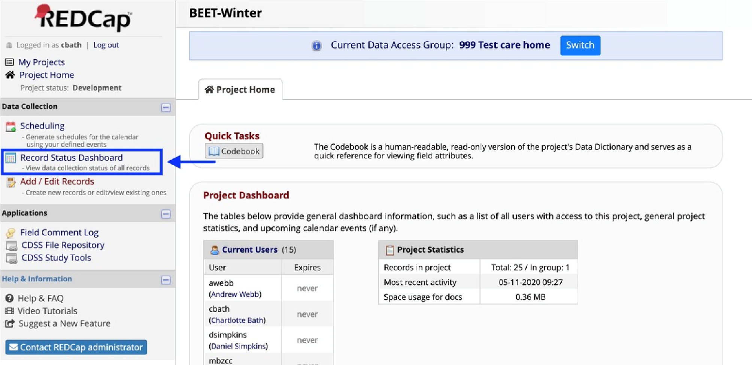

Once in the dashboard, any resident record can be selected which will take you through to the individual resident’s record (Fig 9).

Fig 9.

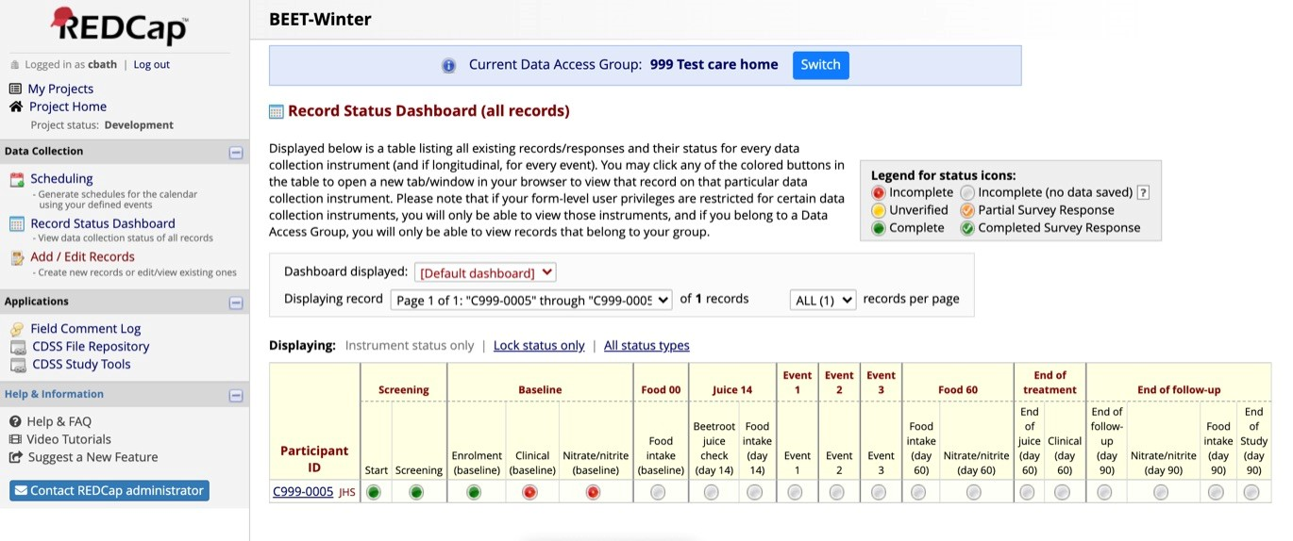

Contact the Trial Manager or Trial Coordinator if you are having problems entering data.

11.3 Summary of Forms (in order)

Screening Forms

- Resident’s Capacity
Date to be completed: Before baseline
Requirements: To create new Resident entry and confirm capacity status.

This database form starts to create a new resident entry. If the resident does not have capacity, details for the resident’s next of kin (Consultee) should be entered.

- Consent Form
Date to be completed: Before baseline
Requirements: To confirm consent has been given by the resident.

This database form requires the resident to answer questions and sign their name on the digital form (see section 5.6).

- Consultee Advice Form
Date to be completed: Before baseline (if resident does not have capacity).
Requirements: To confirm consent has been given by the resident’s relative/ next of kin.

This database form starts to create a new resident entry (see section 5.6).

- Start Form
Date to be completed: Before baseline
Requirements: To create new Resident entry.

This database form summarises the layout and style of the following forms. It is purely informative.

- Screening Form
Date to be completed: Before baseline
Requirements: To confirm eligibility for the trial.

This database form confirms that the resident agrees to take the nitrate drink (having tested it) and fulfils the other inclusion criteria, including consent.

Enrolment Forms

- Enrolment Start Form
Date to be completed: At baseline (before consumption of juice)
Requirements: Access to Resident’s care records

This database form collects baseline information including identifiers (name, date of birth), demographics (sex, race-ethnicity), admission date to Care Home, presence of an advance directive to not be admitted to hospital, and any current infections.

- Medical History Form
Date to be completed: At baseline (before consumption of juice) Requirements: Access to Resident’s care records including medical history

This database form collects baseline information on the resident’s medical history (including diabetes, high blood pressure),

- Vitals Form
Date to be completed: At baseline (before consumption of juice) Requirements: Access to Resident’s care records on recent weight and height.

This database form collects baseline information on the resident’s weight and height.

- Drugs and Vaccination History Form
Date to be completed: At baseline (before consumption of juice) Requirements: Access to Resident’s care records

This database form collects baseline information on the resident’s vaccination and medication history.

- EQ5D Form
Date to be completed: At baseline (before consumption of juice) Requirements: If the resident does not have capacity, someone (carer or family) who knows the resident well should answer. Please do not help the Resident answer the questions.

This database form collects information on quality of life (Euro quality of life visual analogue test).

- Clinical Frailty Scale Form
Date to be completed: At baseline (before consumption of juice) Requirements: If the resident does not have capacity, someone (carer or family) who knows the resident well should answer. Please do not help the Resident answer the questions.

This database form collects information on the resident’s frailty (Rockwood).

- Cognition Impairment Test Form
Date to be completed: At baseline (before consumption of juice)
Requirements: The carer / nurse will need to ask the resident questions. If the resident does not have capacity to answer, scores should be marked as incorrect.

This database form collects information on the resident’s cognition (6item cognition impairment test) using standard brief tests.

- Barthel Index Form
Date to be completed: At baseline (before consumption of juice) Requirements: If the resident does not have capacity, someone (carer or family) who knows the resident well should answer. Please do not help the Resident answer the questions.

This database form collects information on the resident’s activities of daily living (Barthel index).

- Nitrate and nitrite measurement in urine and saliva Form
Date to be completed: At baseline (before consumption of juice) Requirements: Enter if urinary and salivary nitrate and nitrite measurements performed (see section 8).

This database form collects urine nitrate and nitrite, and saliva nitrate and nitrate concentrations.

- Food Intake Form
Date to be completed: At baseline (before consumption of juice) Requirements: Enter if menu and photos of resident’s food (before and after consumption) are collected.

This database form collects the menu and photos of the resident’s food from a meal before and after consumption (see section 9).

Day 14 Forms

- Beetroot juice follow-up Form
Date to be completed: On day 14 of taking the juice (or up to two days after)
Requirements: Use daily medication/consumption logs to record the number of beetroot juices consumed to date by the resident.

This database form collects data on the consumption of juice over the first 14 days. If the resident has consumed less than 50% of the juice shots, the questionnaire will prompt that the nurse/carer should ask the resident if they are happy to continue drinking the juice (see section 8).

- Food Intake Form
Date to be completed: On day 14 of taking the juice (or two days before or after)
Requirements: Enter if menu and photos of resident’s food (before and after consumption) are collected.

As for Food Intake at baseline.

Event Forms

- First/Second/Third Event Forms
Date to be completed: Soon after the resident’s symptoms start Requirements: These forms are to be used for any medical event that affects the Resident e.g.
- develops an infection, whether related to chest, gastrointestinal, urinary, skin or any other type
- has a stroke or heart attack
- suffers a fall or needs an operation that requires hospitalisation
- resident dies

This database form collects information on the first set of symptoms (speed of onset, date of onset, type of symptoms) that develop after starting the beetroot juice. It then collects information on the diagnosis. Please complete this form soon after the resident’s symptoms start. If all of the information required to complete the form is not available at the time, please remember to go back and complete the form when you have the information.

Day 60 Forms

- Food Intake Form
Date to be completed: On day 60 of taking the juice (final day of juice)

As for Food Intake at baseline.

- Nitrate and nitrite measurement in urine and saliva Form Date to be completed: On day 60 of taking the juice (final day of juice)

As per Nitrate/nitrite form at baseline.

- EQ5D Form
Date to be completed: On day 60 of taking the juice (final day of juice)

As per EQ5D form at baseline.

- Clinical Frailty Scale Form
Dated to be completed: On day 60 of taking the juice (final day of juice)

As per Clinical Frailty Scale form at baseline.

- Cognition Impairment Test Form
Date to be completed: On day 60 of taking the juice (final day of juice)

As per Cognition Impairment Test form at baseline.

- Barthel Index Form
Date to be completed: On day 60 of taking the juice (final day of juice)

As per Barthel Index form at baseline.

- End of juice Form
Date to be completed: To be completed on day 60 of taking the juice (final day of juice)
Requirements: Access to Resident’s care records including medical history.

This form asks about the number of beetroot shots taken, whether any side effects occurred, where the resident is currently, whether the resident has had COVID-19 since starting beetroot juice, and whether any (further) infection occurred.

- Clinical Start
Date to be completed: To be completed on day 1 of taking the juice (first day of juice)
Requirements: If the resident does not have capacity, someone (carer of family) who knows the resident well should answer. Please do not help the resident answer the questions.

As per Clinical Form at baseline.

- Clinical End
Date to be completed: To be completed on day 60 of taking the juice (final day of juice)
Requirements: If the resident does not have capacity, someone (carer of family) who knows the resident well should answer. Please do not help the resident answer the questions.

As per Clinical Form at baseline.

Day 90 Forms

- End of follow-up Form
Date to be completed: On day 90 (30 days after final juice consumption)

This database form asks about where the resident is currently, whether the resident has had COVID-19 since finishing beetroot juice, and whether any (further) infection occurred after finishing beetroot juice.

- Nitrate and nitrite measurement in urine and saliva Form
Date to be completed: On day 90 (30 days after final day of juice)

As per Nitrate/nitrite form at baseline.

- Food Intake Form
Date to be completed: On day 90 (30 days after final day of juice).

As for Food Intake at baseline.

- End of trial Form
Date to be completed: On day 90 (30 days after final juice consumption)

This database form asks about whether the resident stopped treatment early (and if so why) and then for the Care Home Manager to sign off the resident from the trial.

12. WITHDRAWING FROM THE TRIAL, STOPPING TREATMENT OR MISSING A FOLLOW-UP

Withdrawing from the trial. This means that the Resident does not want to continue in the trial in any way, i.e. they want to stop the beetroot shots and do not want any more follow-up. This is unusual in most trials, so please talk with the Resident and check that this is what they really mean - the Resident may have really wanted to just stop the juice rather than the whole trial. Although the resident does not have to give a reason(s), please record any reason, if given, in the End of Study form. Please inform the Trial Coordinator via email if a resident withdraws from the trial..

Stopping treatment. This means that the Resident does not want to take any more beetroot shots so please stop giving them for the rest of the 60 days. But first please remind them that the trial is aiming to reduce winter-infections so that they may gain some benefit from taking the shots. If the resident confirms that they wish to stop, although they do not have to give a reason(s), please record any in the End of Study form if they do give a reason. Please continue to follow-up the Resident and complete all the remaining forms.

Missing a follow-up. This means the Resident does not want to answer questions in one of the forms. Try coming back at another time when they may be more willing to complete the form. If necessary, please see if they will answer at least some of the questions even if not all.

13. SUMMARY OF THE TRIAL

Trial Flowchart
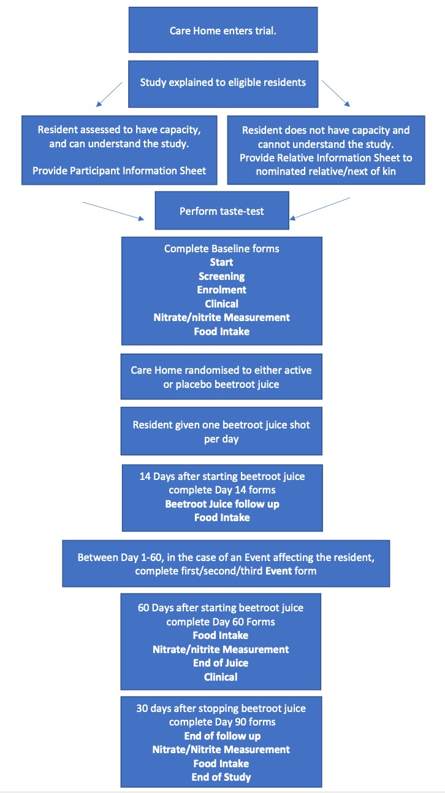

14. FREQUENTLY ASKED QUESTIONS

SECTION 5: ENROLLING RESIDENTS - FAQ

How many residents do I need to find? Altogether, we need between 12 and 17 residents to take part in each Care Home.

What happens if I cannot find at least 12 residents? Enrolling 12 residents is optimal. In the event that the care home manager is unable to recruit 12 residents, they should consult with the trial coordinator.

Can a resident be enrolled with a current infection? As long as an infection has not resulted in hospitalisation, a resident can be enrolled in the trial. An event form should only be completed if this infection worsens, i.e. requires Healthcare advice or Hospitalisation.

What if someone needs to start a course of antibacterial mouthwash after they have begun the trial? Once a resident has been enrolled in the trial, then any treatments such as antibacterial mouthwash can be carried out as usual. There is no need to stop taking the beetroot juice, but as an infection has taken place (such as oral thrush/candida), an Event form will need to be completed.

Can a resident take nutritional supplements during the trial? Yes, a resident can be enrolled in the trial if they are taking nutritional supplements (as long as this is not beetroot juice).

Can residents be enrolled if their food is fortified?
If your care home fortifies a resident’s food (increasing protein and/or calories with foods like whey powder) it is fine for them to be enrolled in the trial.

SECTION 7: BEETROOT JUICE - FAQ

How are the nitrates removed to make inactive beetroot juice? The inactive juice has the same ingredients as the active juice. In order to remove the naturally occurring nitrates, the juice is passed through a microporous selective strong base anion resin. This process does not add any other ingredients to the juice and also avoids the risk of allergens and other cross contamination.

How do I know if the Resident can take beetroot juice? Like many foods, most people like or at least will tolerate beetroot juice, but some will not. Therefore, we will provide extra juices so each resident can try them first. If they are interested in the trial, then please ask them to drink the whole beetroot shot to see if they will take it for another 60 days.

Can beetroot juice be taken by people with diabetes? Yes. Although the juice contains some sugar, it has been tested safely in people with diabetes.

Can the beetroot juice shots be mixed with anything? Yes, beetroot juice can be mixed with other fruit or vegetable juices (apple, carrot etc) or diluted with water. It can also be served chilled or be drunk with a straw if this is helpful to the resident.

How can I tell whether the beetroot juice shots contain nitrate (nitric oxide)? Half of participating Care Homes in the trial will receive nitrate containing beetroot juice, and the other half of Care Homes will receive beetroot juice shots that has no nitrate in it. The shots are identical to look at, and the juice looks, smells and tastes the same. No-one in the trial (apart from the statistician) will know which Care Home and residents are receiving nitrate-containing or nitrate-free juice.

What happens if the resident misses a daily beetroot juice shot? Do not worry about this. Ideally they can take the juice later in the day and then carry on as normal the next day. If a dose is missed altogether, then there is no need to take two shots the next day. Please keep a record of missed doses so this can be entered at the end of the 60 days.

What happens if the Resident refuses to take further beetroot shots if they have started the trial? At Day 14 of the trial, there will be a short questionnaire to complete which asks how many juices have been consumed over the first 14 days. If less than 50% have been drunk by the resident, the form will ask whether the resident wants to keep drinking the juice. If the resident wishes to stop, providing they are willing to stay in the trial for follow-up, then they simply stop the beetroot juice shots and continue with all the other trial procedures. Should this happen, then the care home manager should let the Trial Team/Trial Coordinator know by email or phone. The Trial Team may ask for the care home to recruit another resident into the trial.

The resident can choose to stop drinking the juice at any point in the trial. As above, please let the Trial Team know by email or phone if the resident refuses to consume any more juice shots.

How should empty shots be disposed of? The shots come in plastic tubes and should be rinsed out then placed for recycling.

Can anyone else drink the beetroot juice shots? They must not be drunk by anyone else - not only are they expensive and belong to the trial but half will have no nitrate in them and so offer no potential advantage.

What happens if the Resident is hospitalised at some point during the trial? If a resident is hospitalised during the trial, they should no longer take the beetroot juice (i.e. they are not required to drink it in hospital). As a medical event has occurred, this will need to be recorded in an Event form (section 11.7).

SECTION 8: MEASURING URINARY AND SALIVARY NITRATE AND
NITRITE

How important is it to get both a urine and saliva sample for the dip stick test at the start and end of the trial? Assuming it’s practical, we would like dip stick tests for both urine and saliva. However, if both is tricky to obtain from a resident, a dip stick test on just saliva is preferable as this will give us both a nitrate and nitrite reading (whereas a urine sample will only give a nitrate reading).

Do the samples of urine and saliva, and the used dip stick need to be stored? The salivary/urine nitrate/nitrite concentrations will be measured immediately after collection. Once the levels have been recorded and photographed, both the samples and strips should then be disposed into clinical waste containers. Nothing should be stored.

